Union Bridge Fire Company
12th Annual
Golf Tournament

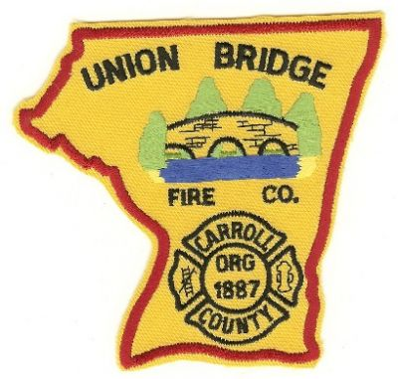
Friday June 15, 2018
at
Glade Valley Golf Club
Walkersville, MD

This will be a shotgun start at 8am
Registration Starts at 7am
$75 per player and $300 per team
Tournament is best ball format

Tournament Includes
18 Holes of Golf, Range Balls, Cart, Hot dogs, beer, soda and water on Course as well as Donuts and Coffee at Registration, Meal and Prizes at Club House at Conclusion of Tournament

For Information Contact
Eric Wetzel 410-596-6253 or Email FFWetzel@msn.com
You can also visit our website at www.ubfc8.org

ALL PROCEEDS FROM TOURNAMENT GO TO SUPPORT
UNION BRIDGE FIRE COMPANY

TEAR OFF AND SEND BACK WITH PAYMENT TO: UNION BRIDGE FIRE Co. GOLF TOURNAMENT PO BOX 1050 UNION BRIDGE MD 21791
Players
1_________________________ 2________________________

3_________________________ 4________________________
Contact Information (Name, Address, Phone):

